Arizona Law Enforcement
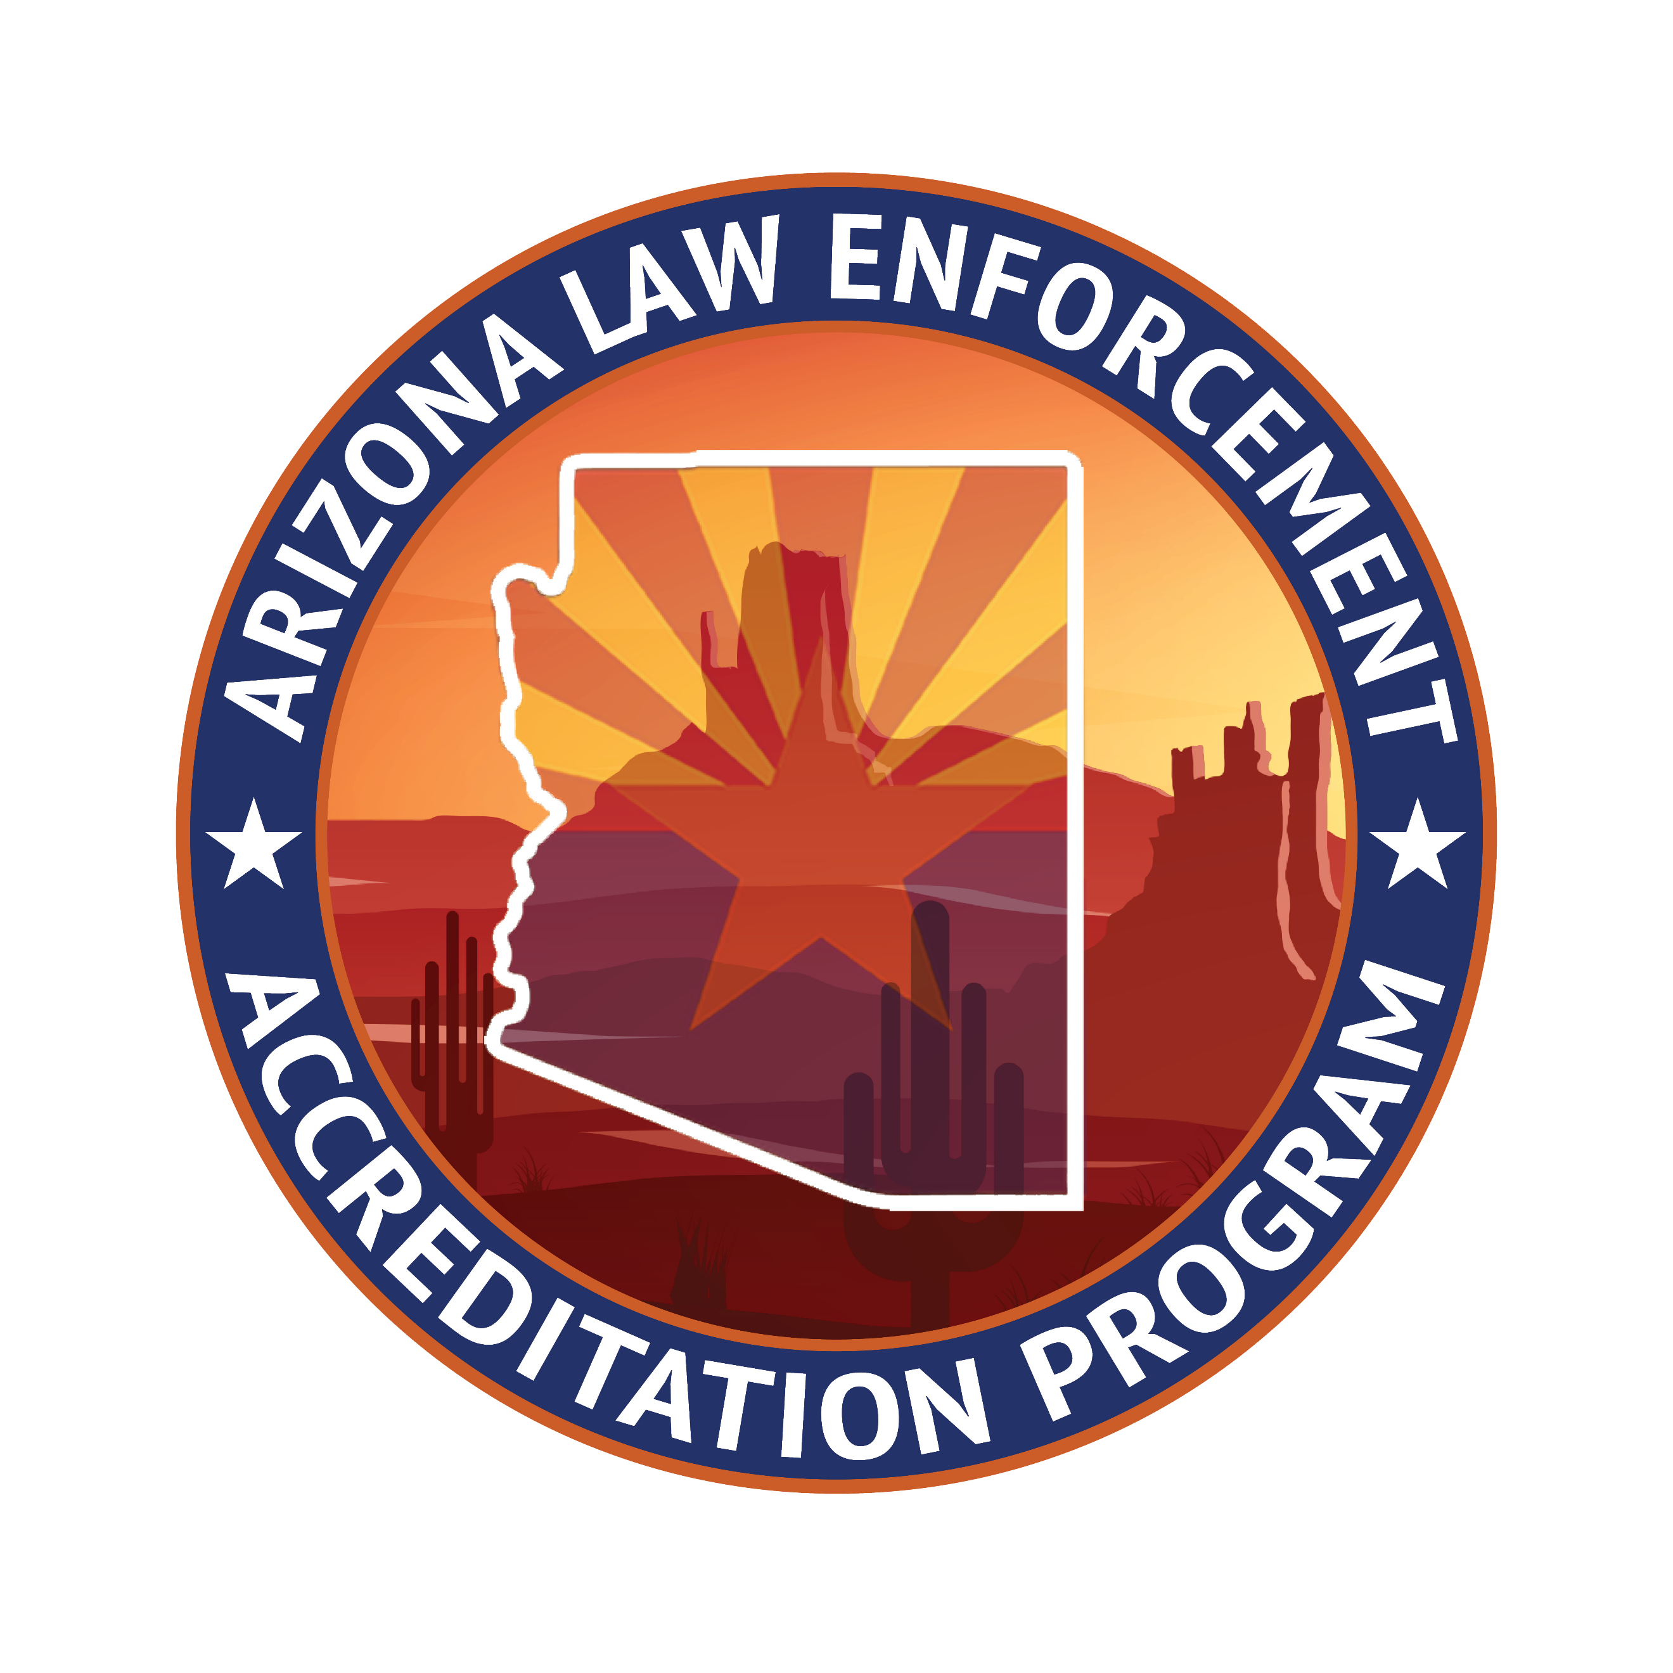
Accreditation Program

STANDARDS REVISION FORM

Standard # ____________

New Standard |  | Revision |  | Deletion

Proposal (State the standard exactly as you believe it should appear in the manual).

Rationale for revision.

Proposed by: ___________________________

Date submitted __________________________

Commission Hearing Date_______________________________

All proposed revisions will be submitted to the Standards Review Committee for consideration.
Forward to: Program Manager Kevin Rhea at kevin.rhea@azchiefsofpolice.org

Approved__________ Disapproved____________ Approved with changes__________

Notes:

